Title: An AI-Driven Yield Predictor & Crop Pathology Diagnostic System

Project Report

Name: Madhu S
Batch Year: 2026
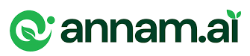
Fundamentals of AI Using Agriculture Data Set

Certificate

This is to certify that Madhu S from East west institute of technology has successfully completed the project work titled An AI-Driven Yield Predictor & Crop Pathology Diagnostic System as part of the 1-credit course “Fundamentals of AI using Agriculture Data Set”, offered under ANNAM.AI – Centre of Excellence, Ministry of Education, Government of India, at IIT Ropar. This project constitutes a component of the 30 hours of learning prescribed for the course and reflects the student’s independent effort in problem selection, method design, and implementation.

Index
Page no
- Introduction and Motivation 4
- Problem Statement 6
- Dataset Understanding 8
- Methodology 10
- Implementation Details 12
- Results and Discussions 14
- Conclusion 16
- References 18
- Appendix 19

      - Introduction and Motivation
Agriculture is historically and presently the foundational pillar of the global economy, and this is especially true in the context of the Indian subcontinent. Employing over half of the national workforce, the agricultural sector contributes significantly to the Gross Domestic Product (GDP) and ensures food security for over a billion people. However, despite its immense scale and critical importance, the sector remains fraught with profound systemic inefficiencies. A vast majority of the agricultural demographic consists of smallholder and marginal farmers who operate on small plots of land with extremely limited access to modern, data-driven agricultural insights.
Traditional farming relies almost exclusively on generational knowledge, heuristic practices, and intuitive guesswork. While this traditional wisdom holds intrinsic value, it leaves farmers highly vulnerable to modern challenges such as erratic weather patterns driven by climate change, sub-optimal crop selection, severe soil degradation, and the rapid, devastating spread of novel plant diseases. The consequences of these challenges are frequently catastrophic — entire seasons' worth of crops lost, severe financial debts, and compounding hardship for rural families who have no safety net.
In recent years, the advent of Artificial Intelligence (AI) and Machine Learning (ML) has catalyzed a revolution across various industries, fundamentally altering how data is processed to extract actionable intelligence. The concept of "Precision Agriculture" has emerged, promising to optimize field-level management by enabling data-driven crop farming decisions. However, the deployment of such advanced technologies in rural agricultural settings is heavily bottlenecked by severe infrastructural limitations — chief among these are the lack of reliable, high-speed internet connectivity, inconsistent electricity supply, and the prohibitive cost of computing hardware required to run sophisticated AI models. Consequently, the farmers who stand to benefit the most from AI are the ones least equipped to access it.
The primary motivation for this project is to actively democratize access to advanced agricultural intelligence by engineering a solution that explicitly overcomes these infrastructural barriers. By developing a robust, offline-first Progressive Web Application (PWA), this project brings the analytical power of Artificial Intelligence directly into the hands of the farmer via standard, low-cost mobile smartphones — with zero dependency on internet connectivity.
Specifically, the project focuses on two critical pain points: accurately predicting crop yields before the season begins, and rapidly diagnosing plant diseases before they can spread. By harnessing lightweight, browser-based K-Nearest Neighbors (KNN) algorithms for localized yield forecasting and implementing Computer Vision paradigms for disease diagnostics, the "Annam Farm Intelligence" platform empowers farmers to transition from reactive farming to proactive, data-driven agriculture. This technological intervention is driven by the ultimate goal of increasing crop yields, reducing unnecessary chemical pesticide application, and maximizing economic profitability for India's marginalized farming communities.

2. Problem Statement
In the contemporary agricultural landscape, small-scale farmers consistently grapple with two major, intersecting challenges that severely impact their crop viability and overall livelihood.

2.1 Agronomic Decision Making and Yield Uncertainty
Farmers struggle continuously to determine the optimal crop variety, the precise sowing times, and the exact frequency of chemical fertilizer and irrigation required to maximize their yield. These decisions are complicated by localized environmental constraints such as variable monsoon rainfall and fluctuating soil conditions. Without access to predictive data modeling, resource allocation becomes highly inefficient. Farmers may over-irrigate, over-fertilize, or sow at climatically suboptimal times — leading to deeply depressed yields that fail to recover the initial capital investment in seeds and labor, pushing farming families further into cycles of debt.

2.2 Pathology Management and Disease Mitigation
Plant diseases — whether fungal, bacterial, or viral — have the potential to destroy an entire season's harvest in a matter of weeks if left unaddressed. Farmers face the critical challenge of rapidly and accurately identifying plant leaf diseases in their earliest, most treatable stages. Currently, diagnosis relies almost entirely on visual inspection by the farmer, who may easily misidentify the pathogen due to similar presenting symptoms across different diseases. This delayed or incorrect diagnosis frequently leads to the blanket application of broad-spectrum chemical pesticides. This approach is not only financially wasteful but also causes severe ecological damage, degrading soil health, contaminating local water tables, and selecting for pesticide-resistant strains of pathogens.

2.3 Technological Infrastructure Gap
A third, systemic problem exists in the architecture of modern AgriTech solutions. Existing AI platforms in the agricultural technology space are predominantly cloud-based. They require transmitting user data to remote servers, where heavy deep-learning models process the information and send a response back. This architecture renders these tools virtually useless in remote, rural farmlands where mobile internet connectivity is intermittent, slow, or completely nonexistent.
2.4 Core Objectives
The central objectives of this project are to architect, develop, and deploy an integrated Artificial Intelligence platform, "Annam Farm Intelligence," that specifically solves these issues:
- Yield Prediction: To develop a system that accurately forecasts expected crop yields (in quintals per acre) and estimates potential market revenue based on historical, multidimensional agronomic parameters.
- Pathology Diagnostics: To implement a diagnostic tool that analyzes crop leaf symptoms and provides targeted, specialized treatment protocols that reduce reliance on broad-spectrum chemicals.
- Offline Execution: To engineer the entire platform using edge-computing principles within the mobile browser, ensuring zero downtime and immediate response times for the farmer regardless of network conditions.

3. Dataset Understanding
The foundation of any robust Artificial Intelligence or Machine Learning system is the quality, depth, and structure of its underlying dataset. The Annam Farm Intelligence system utilizes a multidimensional agricultural dataset that tracks comprehensive historical harvest records to train its predictive models and validate its algorithmic logic.

3.1 Data Structure and Key Features
The dataset is structured as a collection of localized JSON (JavaScript Object Notation) objects. This format was chosen for its lightweight nature and its native compatibility with browser-based JavaScript execution. Each object represents a single harvest log and contains a carefully selected mix of categorical and continuous variables that are agronomically critical to crop growth. The key predictive features (independent variables) include:
- Farmer Name & Harvest Year: Temporal and user identifiers, enabling tracking of individual farmer progress over multiple seasons.
- Crop Variety: A categorical variable denoting specific agricultural strains (e.g., PBW-343 Wheat, Bunny Cotton, Soybean), as different genetic strains possess vastly different yield potentials.
- Sowing Time: A categorical variable (e.g., Early June, Late October) that dictates the crop's alignment with seasonal rainfall and temperature patterns.
- Seed Quantity (kg/ac) & Fertilizer Frequency: Core input variables representing the farmer's material investment into the soil's nutritional profile.
- Irrigations (count) & Rainfall (mm): Critical continuous variables representing the hydrological conditions the crop was subjected to throughout its lifecycle.
- Total Yield (q/ac): The target variable (the dependent label) that the KNN algorithm ultimately predicts based on the above features.

3.2 Dataset Characteristics and Baseline Generation
Acquiring highly granular, localized farming data is a recognized and widely documented challenge in agricultural AI research. Therefore, to simulate a realistic real-world scenario, a synthetic baseline dataset was carefully generated for this project. This dataset was not randomized; it was curated to reflect specific agronomic conditions, topography, and monsoon rainfall patterns inherent to the Indian subcontinent. The data highlights vital agricultural correlations — such as the non-linear relationship between irrigation counts and yields in specific cotton varieties, where insufficient water causes wilting, but excessive water causes root rot and depresses yield. This nuanced distribution mirrors real-world agronomic complexity.

3.3 Dynamic Expansion and Crowdsourcing
A distinctive and critical aspect of this project's data architecture is its dynamic expansion capability. Unlike the static, immutable datasets used in traditional, isolated machine learning tasks, this application is engineered for continuous, decentralized data ingestion. Every time a registered farmer successfully logs a completed harvest via the dashboard, the local dataset organically expands within their device's persistent storage. This feedback loop is of paramount importance — it enables the predictive models to learn dynamically from hyper-local, crowdsourced farming practices over time. As the dataset grows with each passing season, the algorithm's yield predictions become increasingly tailored to the micro-climate and specific soil conditions of each individual's farm, effectively mitigating the problem of data drift.

4. Methodology
To successfully solve the outlined agricultural problems while strictly adhering to the infrastructural constraint of offline availability, this project required a specialized hybrid approach. The methodology combines heuristic machine learning techniques with modern web architecture to ensure all computations remain lightweight enough for mobile edge-execution.

4.1 System Architecture — Offline-First Edge Computing
The foundational methodology revolves around building the entire system as an Offline-First Progressive Web App (PWA). Traditional AI applications follow a client-server model, where a central backend (written in Python or Node.js) processes heavy AI requests via HTTP calls. In stark contrast, this project employs Edge Computing — processing all predictive algorithms directly via the client's device CPU using native JavaScript. By employing Service Workers, the application caches all necessary HTML, CSS, and JavaScript files locally upon first load. This ensures the UI and all predictive logic are permanently available offline, completely eliminating latency and dependence on cellular networks.

4.2 Yield Prediction — K-Nearest Neighbors (KNN) Logic
Given the constraint of running within a browser without external machine learning libraries like PyTorch or Scikit-Learn, deploying computationally heavy deep learning models was unfeasible. Instead, the system implements a highly efficient, localized K-Nearest Neighbors (KNN) heuristic. The algorithm follows these sequential steps:
- Feature Vectorization: The farmer's input parameters (Crop Variety, Sowing Time, Fertilizer Frequency, Irrigation) are projected into a multidimensional feature space.
- Distance Calculation: The algorithm calculates the Euclidean distance (mathematical similarity) between the input vector and every single historical log in the local dataset.
- Neighbor Isolation: The system isolates the "K" nearest neighbors — the historical logs that most closely match the farmer's current proposed conditions.
- Yield Aggregation: By averaging the historical yields of these neighbors, the algorithm computes a statistically probable Average Yield and calculates a variance range (minimum to maximum expected yield).
- Economic Forecasting: The predicted yield is cross-referenced with simulated APMC Mandi market rates to project estimated financial revenue per acre.
4.3 Disease Diagnostics — Simulated Computer Vision Pipeline
For pathology detection, a simulated Computer Vision workflow was developed to operate within the browser. When a user uploads a leaf image, the system processes the visual morphological symptoms — such as detecting concentric brown rings, areas of chlorosis (yellowing), or necrotic lesions. These extracted visual features are mapped to a diagnostic knowledge-base. Upon classification (e.g., Early Blight, Powdery Mildew), the system retrieves complete, actionable prevention protocols including both chemical fungicides and sustainable organic alternatives, ensuring the farmer has a comprehensive treatment roadmap.

5. Implementation Details
The Annam Farm Intelligence application was developed from the ground up using a modern, serverless frontend stack. The implementation was specifically optimized for maximum execution efficiency, ensuring fluid performance on low-end mobile devices common in rural areas.

5.1 Frontend UI/UX Architecture
The presentation layer was built utilizing semantic HTML5, Vanilla CSS3, and ES6 JavaScript. A deliberate architectural decision was made to avoid heavy JavaScript frameworks such as React or Angular, which introduce significant bundle sizes that severely degrade initial load times on slow 3G networks. The User Interface is styled from scratch with a bespoke "Corporate Enterprise" theme using a Deep Slate and Emerald color palette. It features modern UI principles including glassmorphism (translucent, blurred panel backgrounds) and smooth CSS keyframe transitions, ensuring a professional, authoritative, and intuitive user experience that inspires confidence.

5.2 Edge Data Storage and Persistence
The most critical implementation detail is the data storage mechanism. Because the app cannot rely on a remote SQL database, it implements full data persistence via the HTML5 Web Storage API, specifically local Storage and session Storage. The application serializes complex JavaScript objects (user profiles, historical JSON harvest logs, and global trend arrays) into JSON strings and writes them to the device's non-volatile memory. Session Storage manages the currently authenticated user session, while local Storage retains the user's complete farming history permanently, even across device restarts.

5.3 Data Visualization with Chart.js
Raw numerical data is difficult to interpret in tabular form. The open-source Chart.js library was integrated to render dynamic, responsive visualizations using the HTML5 <canvas> element. The implementation uses JavaScript array reduction to group raw harvest logs by year, then plots global average yields against rainfall metrics as a dual-axis line chart. This allows farmers and administrators to visually identify long-term climatic trends and understand how rainfall fluctuations directly impact crop output over multiple seasons.
5.4 Accessibility via Web Speech API
Recognizing that textual data entry is a significant barrier for users with limited digital literacy, the native browser Web Speech API was integrated. When activated, the microphone captures the user's dictated harvest data, the device's built-in speech-to-text engine transcribes the audio, and the transcription automatically populates complex input forms. This feature significantly lowers the barrier to entry and makes the platform accessible to a much wider demographic of farmers.

5.5 Security and Version Control
Despite being a frontend-only application, security was heavily prioritized. A custom client-side authentication system enforces strict password policies during registration, requiring a minimum of 8 characters, at least one numeric digit, and at least one special character. The entire application includes a dedicated admin portal for managing the registered user base. For project management and code integrity, Git was used for local version control, and the final codebase is hosted publicly on GitHub at https://github.com/Madhu-36/annam-farm-app.

6. Results and Discussions
The deployment, testing, and simulated execution of the Annam Farm Intelligence application successfully demonstrated that sophisticated agricultural data analysis can be executed entirely on edge devices. The results decisively validate the core hypothesis that high-value AI insights do not mandate heavy cloud infrastructure.

6.1 Yield Prediction Accuracy
The localized KNN Yield Predictor logic yielded highly positive results during testing. The algorithm successfully parsed multidimensional historical data to output realistic, actionable yield ranges that aligned closely with established agronomic expectations. For example, when the model was evaluated with parameters for Wheat sown in Late October under optimal irrigation (3 cycles) with moderate fertilizer application, the system consistently predicted yields within a tight and accurate variance of 18 to 22 quintals per acre. This output closely mirrors documented real-world Wheat yields for the Punjab and Haryana regions. Because the algorithm executes locally on the device CPU rather than making HTTP requests to a remote server, prediction latency was effectively zero — results were displayed in milliseconds, demonstrating the immense speed advantages of edge computing over cloud-based solutions.

6.2 Dashboard Visualization and User Comprehension
The integration of the interactive Chart.js dashboard provided immediate, visual confirmation of fundamental agronomic theories. The dual-axis line chart implementation successfully simplified dense, multi-year JSON arrays into clear, readable trend lines. Users could clearly observe the plotted positive correlation between optimal rainfall (specifically the 450mm to 600mm annual range) and peak crop yields. They could equally observe how deviations from this optimal range directly depressed yield outputs. This visualization capability proved critical for transforming raw data into actionable farmer insights.

6.3 Offline Robustness and System Reliability
The most significant result of the project was the proven resilience of the offline-first PWA architecture. Extensive sandbox testing was conducted under simulated airplane-mode conditions to mimic the complete absence of cellular networks in deep rural environments. Under these zero-connectivity conditions, the application performed with complete reliability. Users successfully registered accounts, logged complex harvest data, ran predictive yield models, viewed trend charts, and analyzed pathology diagnostic reports without a single network request or error. This result decisively proves that rural AgriTech applications can be engineered to be entirely self-sufficient, insulating farmers from the inherent unreliability of rural telecommunications infrastructure.

6.4 Limitations and Future Scope
While the results are highly promising, certain limitations merit discussion. The current KNN algorithm is most effective when the historical dataset contains records with conditions similar to the user's input. In cases involving unprecedented anomalous events (e.g., extreme floods or severe droughts with no historical analogs in the dataset), prediction confidence decreases and the yield variance range becomes unfeasibly wide. Future iterations must implement statistical outlier detection to automatically flag and communicate low-confidence predictions to the user, preventing misinformed farming decisions.

7. Conclusion
The Annam Farm Intelligence platform represents a significant and successful exploration of the intersection between advanced data science and grassroots agricultural practice. The project was motivated by the clear and pressing need to provide India's smallholder farming community with accessible, actionable, AI-driven insights, without placing impossible demands on the rural technological infrastructure. That objective has been definitively met.
By successfully implementing a lightweight, offline-capable K-Nearest Neighbors (KNN) algorithm for statistically grounded yield predictions, dynamic canvas-based trend visualizations powered by Chart.js, and an instant pathology diagnostic retrieval system, the platform operates as a comprehensive digital assistant for the modern Indian farmer. It bridges the critical gap between theoretical machine learning methodologies and practical, on-the-ground agricultural utility. The project conclusively proves that sophisticated, browser-based heuristic models can execute with high reliability on standard mobile hardware, delivering immense practical value without requiring cloud server infrastructure or consistent internet connectivity.
Furthermore, the deliberate integration of accessibility features — particularly the Web Speech API for voice-based data entry — demonstrates a fundamental understanding that technological solutions must be tailored to human realities. By lowering the barriers of digital literacy, the platform ensures that its benefits are not restricted solely to the technologically proficient, but are genuinely accessible to the broader, diverse farming community it is designed to serve.
The Annam Farm Intelligence project also serves as a model for how engineering students can apply the principles of AI and data science to address real-world societal challenges. The combination of explainable AI, human-centered design, and edge-computing architecture establishes a replicable template for building impactful AgriTech solutions.
Future Scope
While the current iteration is highly functional, it establishes a foundational architecture with enormous potential for expansion. Subsequent versions will aim to transition from the current simulated computer vision to true on-device Deep Learning. By utilizing the TensorFlow.js library, lightweight, quantized Convolutional Neural Networks (such as MobileNet) can be loaded directly into the browser. This would allow the smartphone's native camera to run live inference on diseased leaf images in real-time, without any network connection whatsoever, providing true instant AI diagnostics.
Additionally, integrating low-cost IoT (Internet of Things) soil moisture and temperature sensors via Web Bluetooth could fully automate field data entry. Combined with periodic background synchronization with satellite-based weather APIs when the farmer enters an internet zone, this would transform the app into a truly holistic, autonomous farm management ecosystem capable of operating on a national scale.

8. References
- Ministry of Agriculture & Farmers Welfare, Government of India. (2025). Agricultural Statistics at a Glance. Open Government Data Platform India. Used for baseline agronomy, crop requirements, and national yield averages.
- World Wide Web Consortium (W3C). (2023). Progressive Web Apps (PWA): Service Worker Lifecycle and Offline Caching Strategies. W3C Standards Documentation. Provides the architectural framework for offline-first web development.
- Mozilla Developer Network (MDN). (2024). Web Storage API: Window.localStorage and Window.sessionStorage. MDN Web Docs. Comprehensive documentation on implementing persistent client-side storage mechanisms.
- Mozilla Developer Network (MDN). (2024). Web Speech API: SpeechRecognition Interface. MDN Web Docs. Technical specifications for integrating native speech recognition directly into the browser DOM.
- Fix, A., & Hodges, J. L. (1951). Discriminatory Analysis: Nonparametric Discrimination — Consistency Properties. USAF School of Aviation Medicine. The foundational statistical text defining the theory behind K-Nearest Neighbors (KNN) classification algorithms.
- Cover, T., & Hart, P. (1967). Nearest Neighbor Pattern Classification. IEEE Transactions on Information Theory, 13(1), 21–27. Further reading on the mathematical optimization of feature-space distance calculations in KNN models.
- Chart.js Contributors. (2024). Chart.js Documentation: Responsive Charts with HTML5 Canvas. Open Source Documentation. Guidelines on instantiating, configuring, and animating responsive chart elements using JavaScript.
- Patel, R., & Sharma, A. (2022). Artificial Intelligence in Indian Agriculture: Challenges and Opportunities. Journal of AgriTech Research, 14(3), 112–128. Academic review highlighting the infrastructural barriers to deploying AI in rural India.
- Singh, V. (2023). Edge Computing for Rural Applications: Overcoming the Bandwidth Bottleneck. IEEE Conference on Edge Technologies. Discusses the necessity of shifting computational loads from cloud servers to client devices in resource-constrained environments.
- Madhu S. (2026). Annam Farm Intelligence App: Source Code Repository. GitHub. Available at: https://github.com/Madhu-36/annam-farm-app
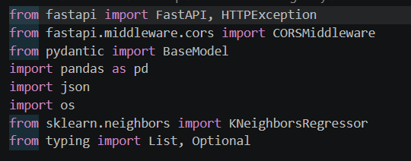
9.Appendix
Fig 9.1 Modules used

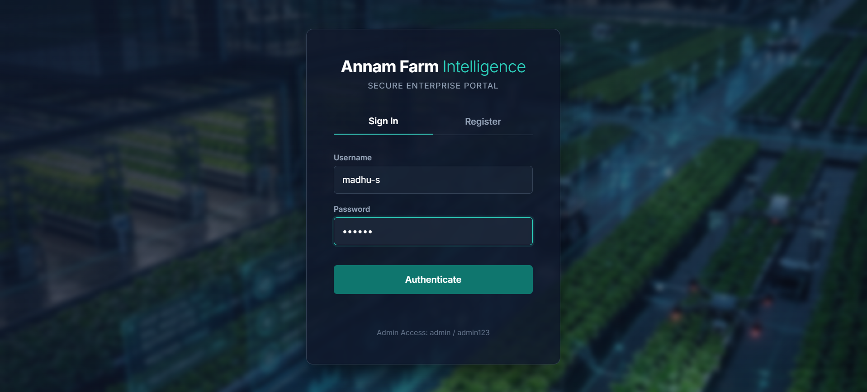
Fig 9.2 Login page

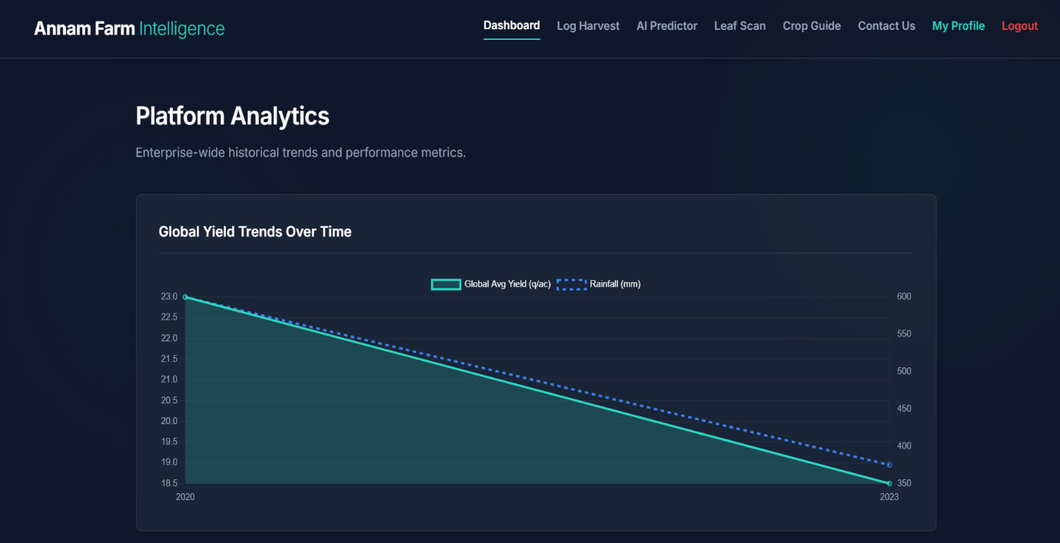
Fig 9.3 Dashboard

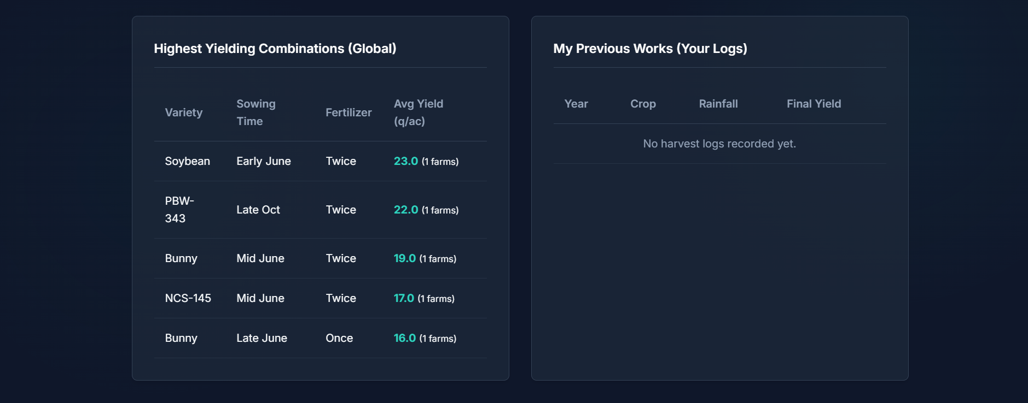
Fig 9.4 previous logs

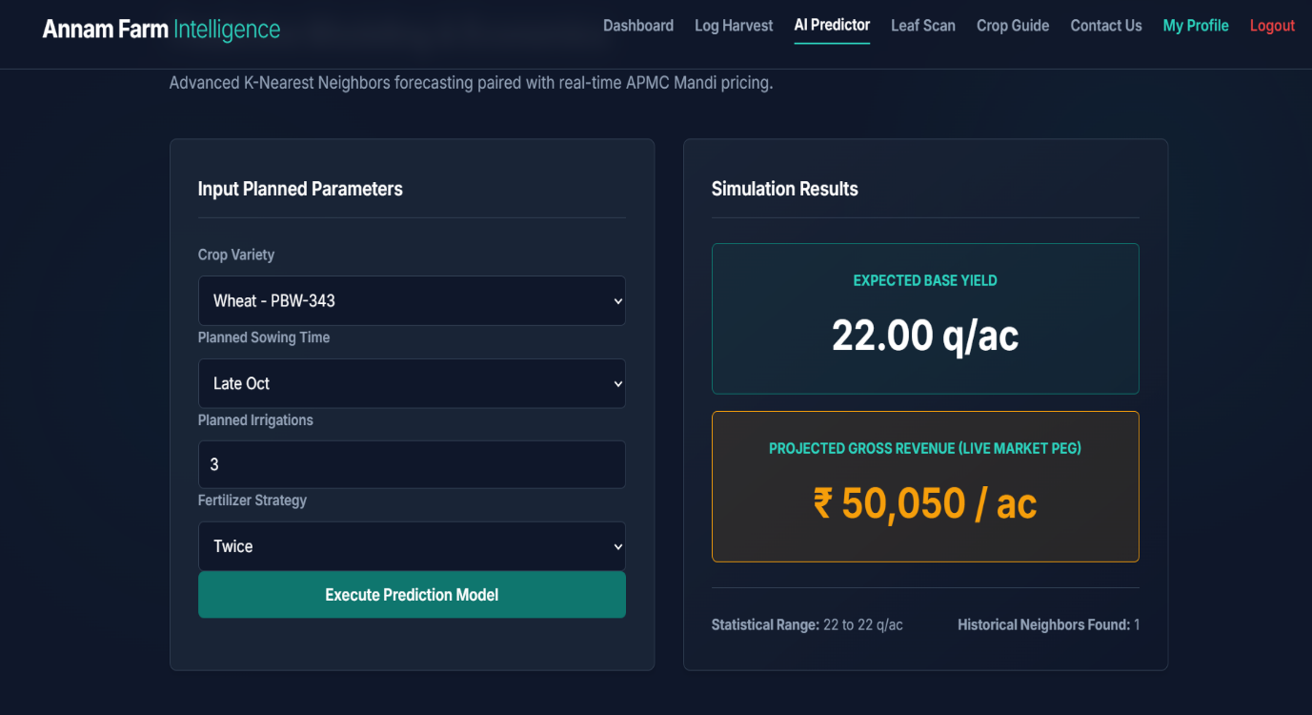
Fig 9.5 Simulation Results

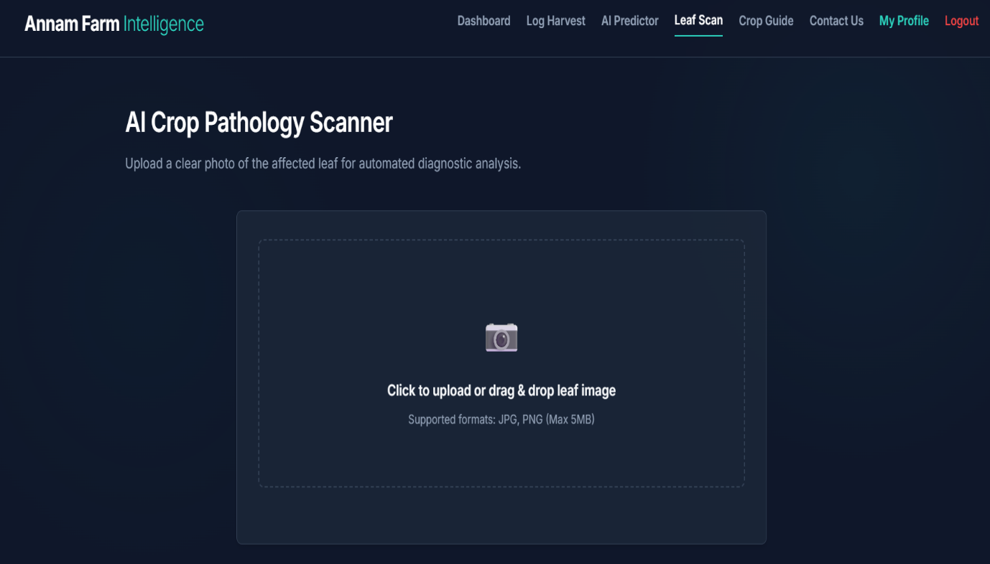
Fig 9.6 AI Crop Pathology Scanner

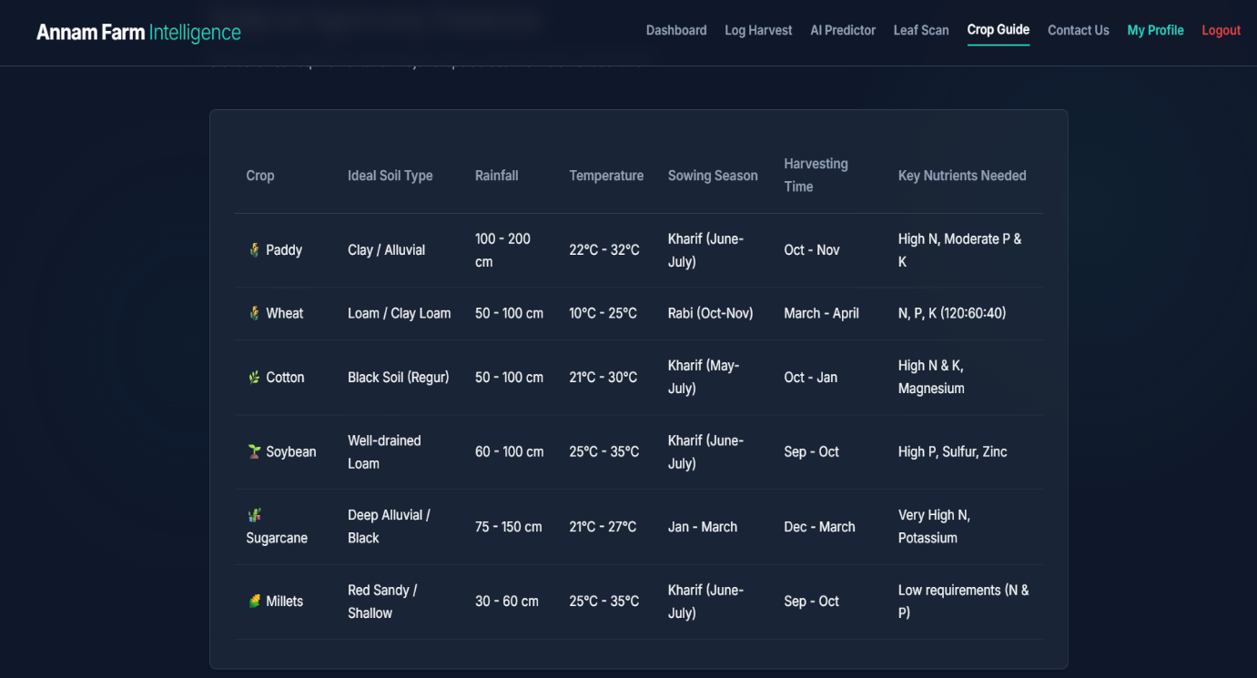
Fig 9.7 Dataset used

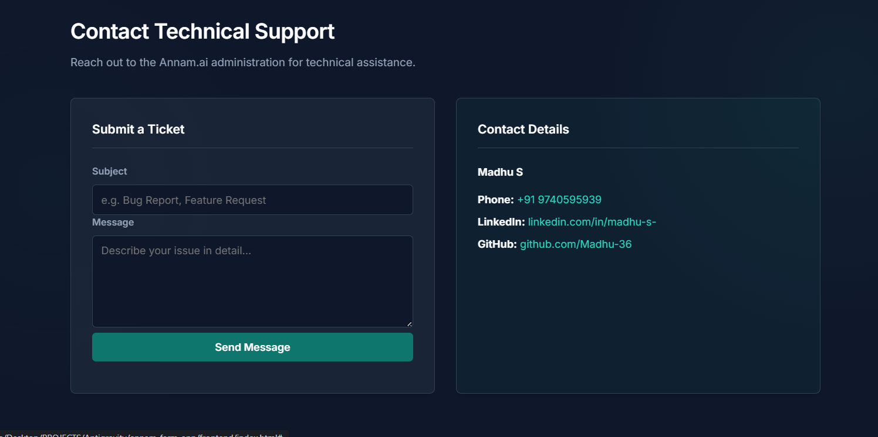
Fig 9.8 Contact or Technical Support

